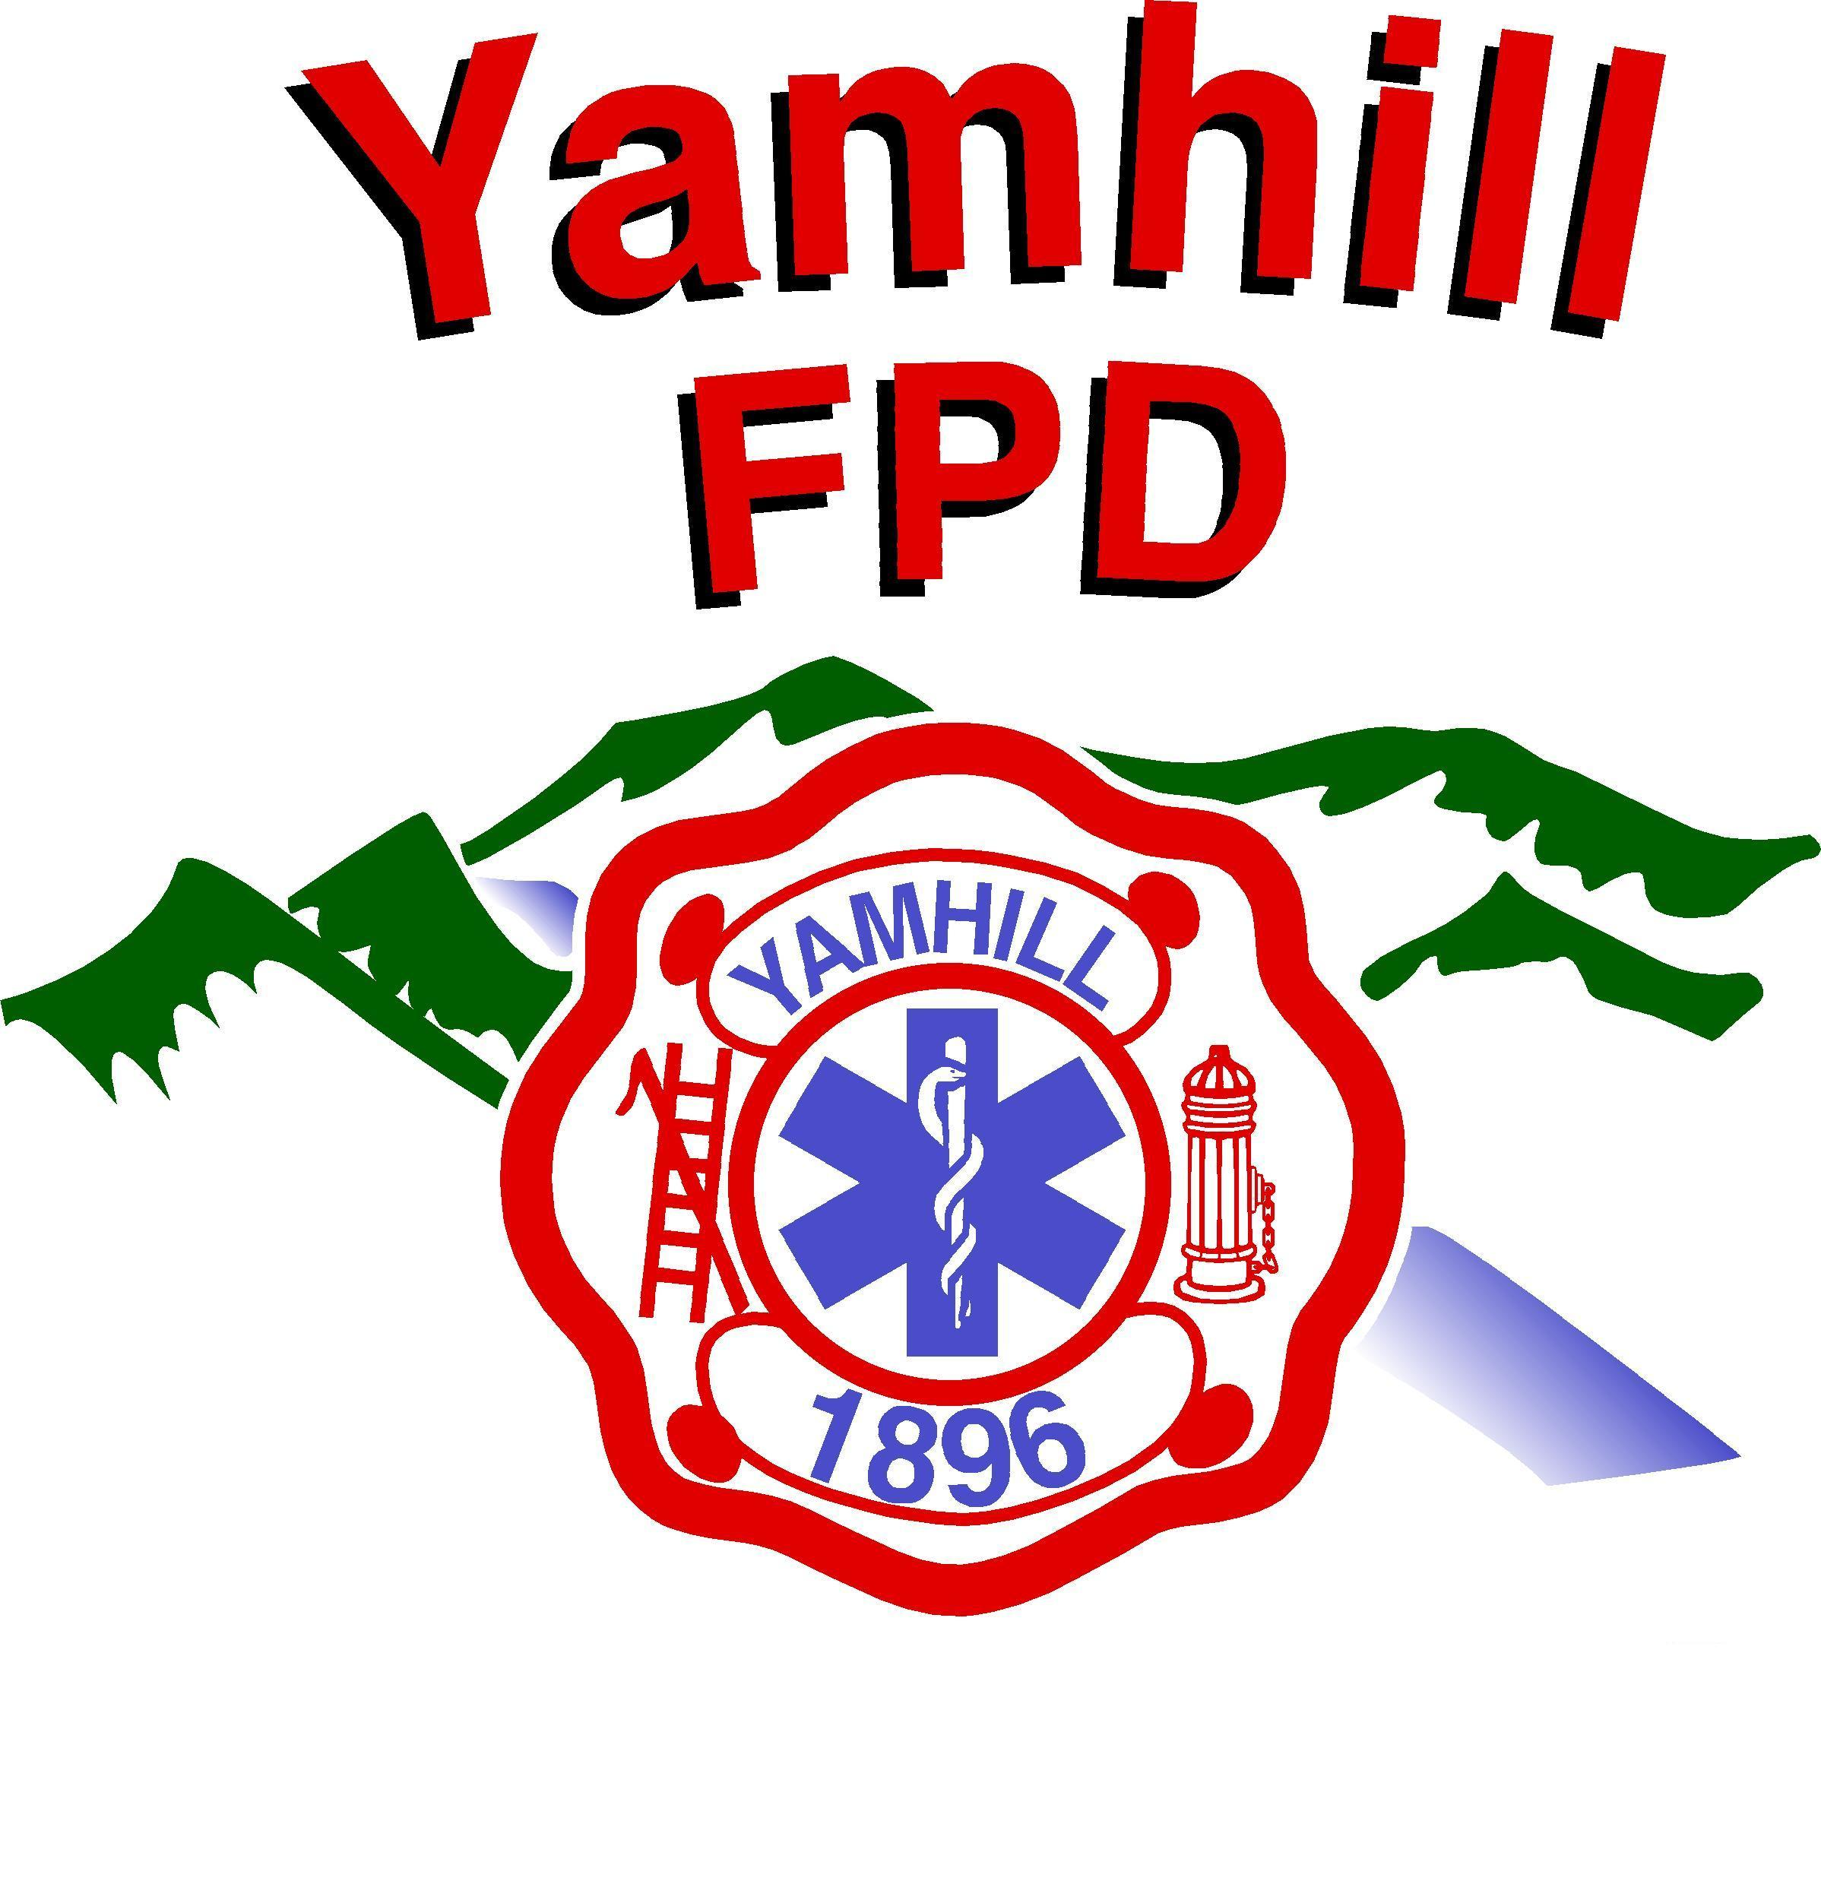
Yamhill Fire Protection District
PO Box 249 – 275 South Olive St.
Yamhill, Oregon 97148-0249
Phone: (503) 662-4653
Fax: (503) 662-3740
http://www.yamhillfire.org
------------------------------------------------------------------------------------------Serving the people of the Yamhill Fire Protection District since 1896

Levy History

On September 16, 1986 an election was held, authorizing the issuance of $75,000 in General
Obligation Bonds. This bond was for a new 1,000-gallon Class A Pumper. The voters approved the measure by 435 to 337.

On March 31, 1987 an election was held, authorizing the issuance of $250,000 in General Obligation
Bonds. This bond was for a new Fire Station. The voters approved the measure by 483 to 299.

These Bond Proceeds where $325,000, a Capital Improvement Reserve Fund of $46,151 and
Interest for $1,000. This provided a total of $372,151. Of those funds, $116,000 was spent for a
New Class A 1,000-gallon Class A Pumper, $20,000 to purchase property for the Fire Station,
$229,651 for construction of a new Fire Station, $1,000 for Architectural and Engineering, and
$5,500 for Bond Issue

The cost to the Tax payers for the $325,000 bond levy was, $0.86 per thousand for 12 years.
The Class A Pumper was paid off in 1997 and the Fire Station was paid off in June of 1999.

The District attempted a 5-year local option tax levy in Nov. 5, 2002 at a rate of $0.53 per thousand.
Funds would have been used to purchase a new Wildland Engine and a Structural Engine. This Levy
Failed 603 yes and 891 no. Lost by 289 votes.

On November 6, 2012 the District attempted a 5-year local option tax levy at the rate of $0.55 per
Thousand. This levy was for replacing the Rescue and staffing. This Levy Failed 759 yes and 1233 no.
Lost by 475 votes.

On May 19, 2015 the District attempted a 10-year Capital Improvement Levy at the rate of $0.55 per
Thousand. This Levy was for replacing the following;
1. 1977 Fire Engine
2. 1995 Fire Engine
3. 2003 Rescue
4. Self-Contained Breathing Apparatus
5. Communication Equipment
6. Building upgrades;
a. Fire Station Roof
b. Station Heating System
c. Exhaust removal system
This Levy Failed 431 yes and 522 no. Lost by 92 votes.

On November 3, 2015 the District attempted a 10-year Capital Improvement Levy at the rate of $0.55 per thousand. This Levy was for replacing the following;
1. 1989 Fire Engine
2. 1995 Fire Engine
3. 2003 Rescue
4. Self-Contained Breathing Apparatus
5. Communication Equipment
6. Building upgrades;
a. Fire Station Roof
b. Station Heating System
c. Exhaust removal system
This Levy Failed 524 yes and 562 no. Lost by 39 votes

The District paid off the bond in June of 1999. For the last 19 years the district hasn’t had any
Additional funding.

