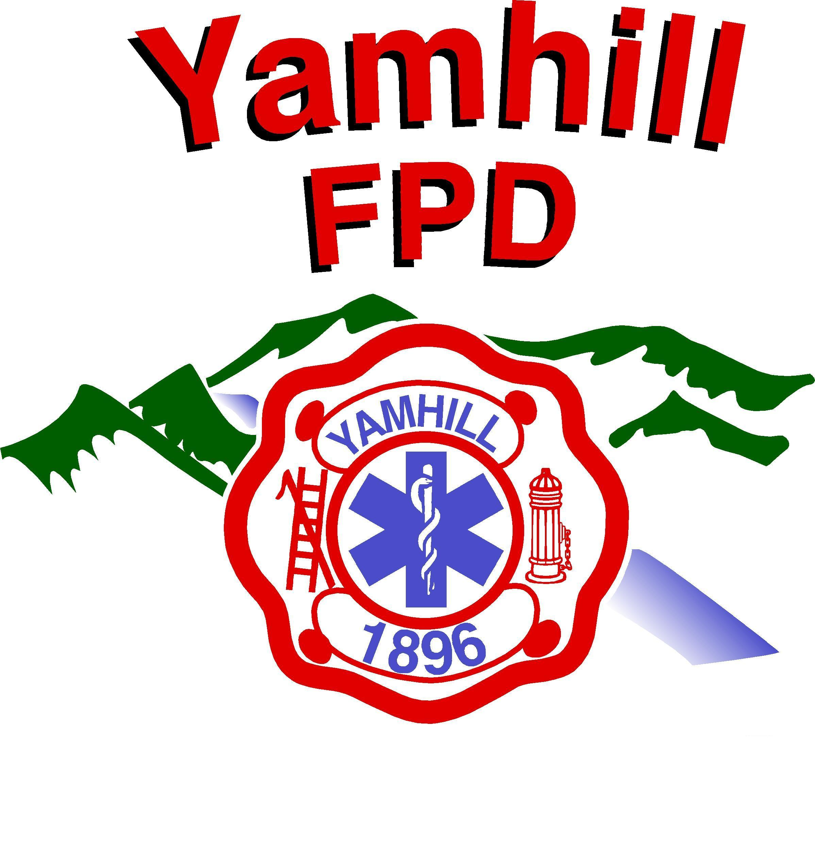
Yamhill Fire Protection District
PO Box 249 – 275 South Olive St.
Yamhill, Oregon 97148-0249
Phone: (503) 662-4653
Fax: (503) 662-3740
http://www.yamhillfire.org
------------------------------------------------------------------------------------------Serving the people of the Yamhill Fire Protection District since 1896

Yamhill Fire Protection District

Apparatus Replacement Plan

June 15, 2018

By Fire Chief

Brian Jensen

Introduction

As the Fire Chief, I have identified and assessed the condition of the District’s existing apparatus, and equipment. With that assessment I have developed a draft of a manageable fleet replacement schedule. These efforts culminated in a comprehensive study that included a survey of all current vehicles in the fire district fleet, and analysis of fire apparatus replacement schedules in various jurisdictions and a proposed apparatus replacement schedule. There are at least three different life cycles to consider: service life, technological life and economic life as well as some immeasurable costs.

The Service Life

The service life of a vehicle is when a piece of equipment is, capable of performing its needed duty. Service life is dependent on a number, of factors, and variables. The most important are mileage,
number of responses, overall wear and tear, pumping capacity and operating capability.

The Technological Life

The technological life of a vehicle is it capability to serve in the role it was initially designed for.
While older vehicles may still be capable of performing the tasks they were designed for, they cannot match the performance requirements of new vehicles. Speed, acceleration and braking ability with new technologies such as antilock braking systems, traction control and rollover stability are some of the new technological advances of newer apparatus.

The Economic Life

The economic life of a vehicle is its total expense for effective use over a given period, of time.
These costs include: depreciation, operating costs, fuel, oil, maintenance, repairs, downtime
replacement and operator training. All these factors come into play when determining the vehicles
Economic life. The cost to maintain a given vehicle increases with time, until it is more expensive to operate than maintain.

Background

In the last twenty years the fire district and the role of our fire apparatus delivery service has
significantly expanded. In addition to fire suppression equipment, fire apparatus is also currently
stocked with the basic medical equipment, rescue equipment, hazardous materials equipment, and
all the tools needed to provide a quick and proper deployment of any nature. Most of the fire district’s fleet was purchased in the 1990’s and is not designed to accommodate the additional equipment loads
or do not meet current standards for fire apparatus. These safety issues include, passenger compartments, lack of ABS and other safety features.

The ages of the District’s apparatus are 29, 27, 23, and 21 years for our front-line engines. The
District current apparatus exceeds the commonly recognized maximum recommended total life span
of 20 years for engines. NFPA 1901 requires that apparatus that does not meet the 1901 standard be removed from front line service and/or be considered for upgrading or replacement. There is a direct
tie between ISO insurance rates and our apparatus fleet. Our current, ISO rating of a Class 4 in the City of Yamhill, requires us to have three pumpers (what we call engines); two front-line and one reserve. While we meet this total number now, two of our engines are well beyond their service life.

Preliminary Recommendation

One of the most important capitol assets of the district is a fleet of reliable automotive and fire
apparatus. Firefighters depend heavily on the performance and capabilities of their vehicle when
operating to protect life, property and the environment. To maximize these capabilities and minimize their risk of injury, it is imperative that the apparatus be equipped with the latest safety features and current operating capabilities.

Replacing fire equipment is necessary, yet a very costly expenditure. Today’s fire apparatus could
cost up to $1,000,000 depending on its specifications and capabilities.

Fire apparatus replacement should be carefully planned out and conducted on a regular basis to
avoid shortfalls within a fleet. Replacement should be based on the service life variables and life
cycles mentioned. Currently there is no replacement plan for these fire apparatus, and I suggest
following the NFPA standard with consideration of our own variables. The following plan for replacement shows the year and value of apparatus, it also will show its expected life cycle,
giving us opportunity in advance to plan for its replacement. The construction life of ordering an
apparatus should also be considered when preparing to replace a piece of equipment.
Some construction times can take up to a full year. This process typically includes approval to
purchase, bid process, award of bid, manufacturer meetings, specifications conference,
acceptance testing and training.

My recommendation is to replace engines on a 25-year cycle of frontline service, with 5 years in
reserve engine status for a total of 30 years, with evaluation of service life every 10 years. Rescue
apparatus should be replaced at 20-years of service. The Command vehicle should be replaced
every 10 years, with it being moved down to the Main or Sub-Station for another 10 years of
service, evaluating life at 10 years. The evaluation of service life for all pieces of apparatus is done throughout life but should have a thorough examination prior to placing it in reserve or down
to the Main or Sub Stations. The following table will show the current deficiencies in our fleet replacement schedule due to vehicle age.

Current vehicles in service

Year & Make | Age | Life Expectancy | Current Value | Status | SRV Life | Tech Life | Econ Life
1989 / Engine  1,000 Gallons | 29 | 30 | 3,500 | Sub - Primary | END | OK | OK
1991 / Engine  500 Gallons | 27 | 30 | 3,500 | Main - MVA | END | OK | OK
1995 / Engine  2,500 Gallons | 23 | 30 | 50,000 | Main - Tender | OK | OK | OK
1997 / Engine  1,500 Gallons | 21 | 30 | 50,000 | Main - Structure | OK | OK | OK
2001 Suburban | 17 | 20 | 2,000 | Main - Personnel | OK | OK | OK
2004 Excursion | 14 | 20 | 8,000 | Command | GOOD | GOOD | GOOD
2004 / Brush  400 Gallons | 14 | 20 | 40,000 | Main - Brush | GOOD | OK | OK
2011 / Rescue | 7 | 20 | 85,000 | Main - Rescue | GOOD | GOOD | GOOD

Options / Recommendation

My recommendation would be to replace as soon as possible the 1991 engine which is nearing
the end of its service and technical life spans. This engine is only equipped with a 500- gallon tank. I would keep it in reserve for a while as a Training Engine. The 1989 engine is older in age but has a 1,000 Gallon tank and is better suited for the Flying M Sub-Station.

The other apparatus remaining apparatus should be evaluated annually and replaced as deemed
necessary. (See attached Replacement Sheet)

There are several options for the purchase of fire apparatus;

1. Purchase the apparatus outright.
2. Lease the apparatus for 5 years and buy it out at the end of the lease period.
3. Lease the apparatus for 10 years and buy it out at the end of the lease period.
4. Lease the apparatus for 10 years and then return it at the end of the lease.
5. Obtain a Loan with the Bank for 5 years to purchase.

No matter which option you decide to go with, it would require one of the following options for a Levy
to provide the funding, as the General Fund is not able to do so.

1. 5 - Year Capital Improvement Levy
2. 10 - Year Capital Improvement Levy
3. Bond Levy (5 to 20 years)

All these options obviously have different weighting factors and practicality, the best choice
for the District would be to do a 5 – year Capital Improvement Levy to purchase the needed
equipment and apparatus. The amount of the annual payment to be made is dependent on,
purchase price, down payment, interest percentage rates and whether it’s on a five or ten year
option. The tables below are an example of the possible costs for an Engine, SCBA’s, and then
both together. (See attached)

Summary

Its common knowledge that the District’s General Fund is bound by the economic restraints that
we all face; If there is no replacement plan established for apparatus and other equipment, it will
soon be extremely difficult, if not irreversible to maintain a fleet of safe and reliable apparatus.
The ongoing annual payment may be easier to plan and budget for than a quarterly or monthly
payment. Also looking at the cost to fund this equipment, it is a cost savings to purchase these items
on a 5 - year plan, instead of a 10 - year plan. Fire apparatus and equipment are a large and
substantial financial burden, but are truly a necessary tool for us to protect life and property for the
citizens of the Yamhill Fire Protection District. I hope that this information has been helpful, and the needs of a replacement plan are understood. If you have any questions, please contact me.

- Attachments

