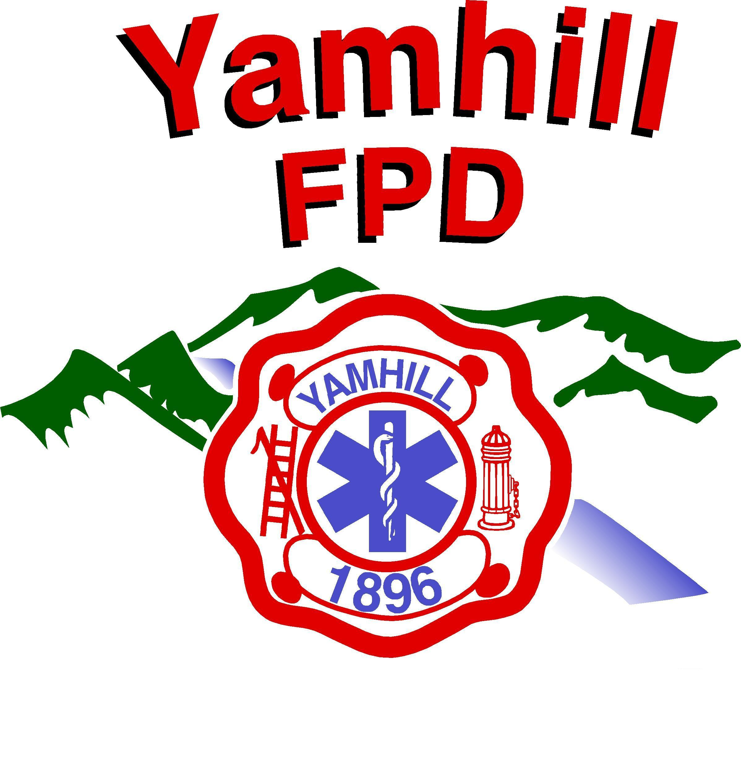
Yamhill Fire Protection District
PO Box 249 – 275 South Olive St.
Yamhill, Oregon 97148-0249
Phone: (503) 662-4653
Fax: (503) 662-3740
http://www.yamhillfire.org
------------------------------------------------------------------------------------------Serving the people of the Yamhill Fire Protection District since 1896

Property Burn Information

Introduction

The Yamhill Fire Protection District is always looking for opportunities to provide realistic, quality
training to our members. One of the ways we accomplish that goal is through live-fire training at
donated structures and properties. The information contained in this packet is designed to help
guide you through the process of having your property burned by the Fire District. Please keep in
mind that these are general guidelines and are subject to change at any time.

What will the Fire District burn?

The Fire District will burn most freestanding structures such as houses, barns, and mobile homes.
We occasionally burn fields or areas of brush in the late spring and early summer as part of our
annual wildland fire training. We do not burn debris piles, tires, or residential/commercial waste.

A member of the Fire District will inspect the structure and/or property to determine if it meets
our training needs and can be safely burned. If so, the District Fire Chief or Training Officer will
contact the property owner to start the planning process.

What if the Fire District will not or can not burn my property?

The Yamhill Fire protection District burns property as a courtesy to the community, but is not under any
obligation to do so. Any property that the Fire District is unwilling or unable to burn must be
demolished or cleared following all applicable Federal, State, and/or Local laws. The Fire
District has the authority to bill property owners for any responses to illegal burning, and will
investigate all suspicious fires. Enclosed in this packet is a fact sheet from the State Department
of Environmental Quality that explains the open burning regulations for the area.

How soon can the property be burned?

There is a considerable amount of preparation and planning required before the Fire District can
conduct a training burn. Because of this, and the fact that most of the personnel involved are
volunteers, we ask for a minimum of 60 days notice. The District does not conduct any live-fire
training during the summer burn ban, which generally runs from July through early October.
Burns are normally conducted on the weekends, and take several hours to complete.

Two dates will be set for the burn, a primary date and an alternate. The Fire District will make all
reasonable attempts to burn the property on the designated date, but does not guarantee that it
will occur as scheduled. Unfavorable weather conditions, emergency calls, or other unplanned
situations may prevent the Fire District from conducting a burn. If a burn must be cancelled, the
property owner will be contacted as soon as possible to make alternate arrangements.

The Yamhill Fire Protection District is not liable for any costs, fees, or penalties a property owner
incurs from the cancellation of a burn.

Is there any cost?

Yes, the Fire District charges $500.00 to conduct a training burn. This money is used to provide
rehabilitation supplies such as food and Gatorade to our firefighters, as well as the members of
other Districts who cover for us on the burn day; the fee also covers any consumables used by
the district or other expenses that might be incurred. Checks should be made out to the Yamhill Fire Protection District.

We also require the property owner to provide suitable bathroom facilities on-site. This
requirement may be met through the use of bathrooms in other structures on the property, or by
the provision of a “port-a-potty” or similar type device. Facilities will be inspected by a
representative of the Fire District prior to the burn to ensure their suitability. Owners who decide
to use a bathroom in an existing structure should be aware that our personnel will be very dirty,
and the Fire District is not responsible for any damages or cleaning costs.

What about liability and insurance issues?

Yamhill Fire Protection District personnel are covered by workers compensation insurance, as well
as the District’s insurance provider, while operating at a training exercise. The Yamhill Fire Protection
District and/or its members will not agree to, or sign any, document or agreement that absolves or
limits the customary responsibilities of a property owner.

What do I have to do?

In this packet is a checklist that outlines the property owner’s responsibilities. They are as
follows:

- Complete the “Waiver of Liability – Release Form”, have it notarized, and return
to the District office with the $500.00 fee at least two weeks before the burn day.
- Contact all applicable utility companies, and have services removed/secured.
- Notify your insurance company and remove all fire insurance.
- Remove all hazardous materials from the property and clean up any hazardous debris
(See below).
- Remove water heaters, boilers, and/or pressure vessels & tanks that could possibly
rupture when heated.
- Make arrangements for on-site bathroom facilities.
- Provide written proof that the structure is asbestos free (See below).
- Contact all applicable city/county agencies and obtain required permits (See below).
- Follow all other special instructions or requirements as specified by the Fire District.

Hazardous materials & asbestos

There can-not be any hazardous chemicals, fuel/oil, tires, or pesticides in or on the property that
is to be burned. The property owner is responsible for the clean-up and removal of such materials,
and any associated costs. A representative of the Fire District will conduct a final inspection
on the day of the burn to ensure that the site is safe and no hazards are present.

Oregon State Department of Environmental Quality regulations strictly prohibit the burning of any structure or materials containing asbestos. The property owner must provide the Fire District written proof from a licensed inspector that the property being burned is asbestos free. You can contact a local real estate agent or home inspector for information on companies that provide this service.

Permits & City/County requirements

The property owner is required to contact the offices listed below and obtain any permits that
may be required. The property owner is solely responsible for any fees that are charged for such
permits.

For Structures and /or property in Yamhill County:

Yamhill County Planning & Development Department
401 NE Evans Street
McMinnville, Oregon 97128
(503) 434-7516

For Structures and/or property in the City of Yamhill:

Contact Yamhill County as above, and

City of Yamhill
205 S Maple Street
Yamhill, Oregon 97148
(503) 662-3511

What happens after the burn?

Fire District personnel will depart the scene once the fire has decayed to the point the
officer-in-command determines that the owner can safely monitor and control it. Once the Fire
District leaves the scene, the property owner is responsible for security of the site and control of
the remaining fire. The property owner is solely responsible for the removal of debris and/or site
clean-up, and any costs associated with such.

On request, the Fire District will provide a letter attesting that the structure or property was
burned for tax or accounting purposes.

